 | curriculum.newvisions.org/social-studies  Timothy Lent - tlent@newvisions.org  Kameelah Rasheed - krasheed@newvisions.org | 
Please Read: We encourage all teachers to modify the materials to meet the needs of their students. To create a version of this document that you can edit:  1. Make sure you are signed into a Google account when you are on the resource.  2. Go to the "File" pull down menu in the upper left hand corner and select "Make a Copy." This will give you a version of the document that you own and can modify. |  | 
Teacher Overview: What were the historical circumstances for the founding of the Ottoman Empire?
Go directly to student-facing materials!

 | SQ 1. Where was the Ottoman Empire? How interconnected was it to other regions? | SQ 2. What was the geographic and historical context for the founding of the Ottoman Empire? | SQ 3. What was the ethnic and religious composition of the Ottoman Empire? | 

 | Unit Essential Question(s): How did the Ottoman Empire and Ming Dynasty gain, consolidate, and maintain power? | Link to Unit
Supporting Question(s):
- What were the historical circumstances for the founding of the Ottoman Empire?
Objective(s):
- Describe the geographic context for the founding of the Ottoman Empire.

1. NYS Social Studies Framework:
Key Idea | Conceptual Understandings | Content Specifications
9.7 THE OTTOMAN EMPIRE AND THE MING DYNASTY PRE-1600: Islam, Neo-Confucianism, and Christianity each influenced the development of regions and shaped key centers of power in the world between 1368 and 1683. The Ottoman Empire and the Ming Dynasty were two powerful states, each with a view of itself and its place in the world. (Standards: 2, 3, 4, 5; Themes: ID, MOV, GEO, SOC, GOV, EXCH) | 9.7a Three belief systems influenced numerous, powerful states and empires across the Eastern Hemisphere. | Students will map the extent of the Ottoman Empire and the Ming Dynasty at the height of their power.  Students will map the extent of the Muslim, Neo-Confucian, and Christian realms and compare the relative size and power of these realms ca. 1400.

2. Social Studies Practices
NYS Social Studies Practices | New Visions Student Social Studies Practices
Gathering, Using and Interpreting Evidence (A5, A7)  Chronological Reasoning and Causation (B1)  Comparison and Contextualization (C3, C5, C6)  Geographic Reasoning (D1, D2, D5) |   Predict Contextualize Think Like a Geographer

3. Common Core
Reading | Writing | Speaking and Listening
Craft and Structure:  CCSS.ELA-LITERACY.RH.9-10.4: Determine the meaning of words and phrases as they are used in a text, including vocabulary describing political, social, or economic aspects of history/social science.  Integration of Knowledge and Ideas:  CCSS.ELA-LITERACY.RH.9-10.7: Integrate quantitative or technical analysis (e.g., charts, research data) with qualitative analysis in print or digital text. | Text Types & Purposes:  CCSS.ELA-LITERACY.WHST.9-10.1: Write arguments focused on discipline-specific content. | Comprehension and Collaboration:  CCSS.ELA-LITERACY.SL.9-10.1: Initiate and participate effectively in a range of collaborative discussions (one-on-one, in groups, and teacher-led) with diverse partners on grades 9-10 topics, texts, and issues, building on others' ideas and expressing their own clearly and persuasively.

Associated Classroom Posters
Student Social Studies Practices Poster

Objective: | What were the historical circumstances for the founding of the Ottoman Empire?  - Describe the historical circumstances for the founding of the Ottoman Empire.
Introduction
Much like the Roman Empire, the Ottoman Empire was able to conquer territories on several continents. Using your prior knowledge, what might the leaders of the Ottoman Empire have done to gain, consolidate, and maintain power?

Contextualize | The Rise of the Ottoman Empire  ➡ Directions: Examine the timeline and images below, then respond to the questions.

The Ottomans were a Muslim Turkish-speaking nomadic people who migrated from Central Asia in northwestern Asia Minor. They quickly conquered other societies and expanded their empire.

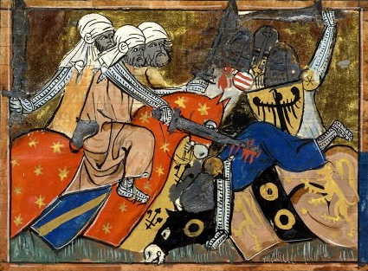  The Battle of Ager Sanguinis, medieval miniature  Image is courtesy of Wikimedia Commons and is public domain. | 1096-1290s: The Crusades were fought between Muslims and Christians.
- Using your prior knowledge, what caused the Crusades?

- How did the Crusades impact the relationship between Christians and Muslims?

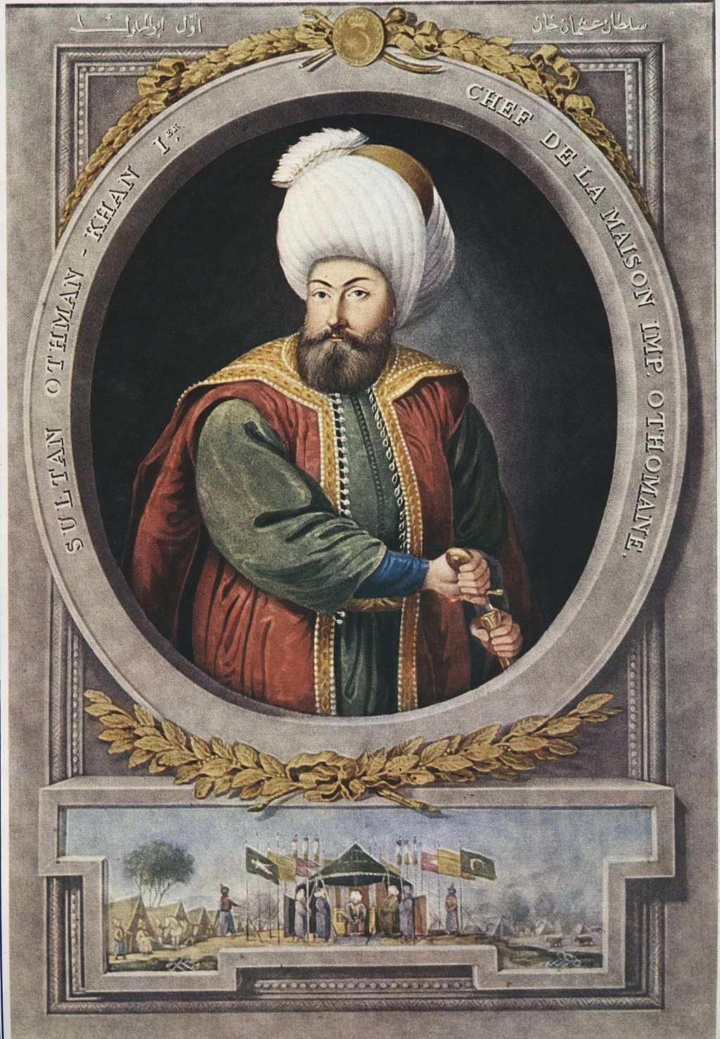  An imagined portrait of Osman I.  Image is courtesy of Wikimedia Commons and is public domain. . | 1326: A leader named Osman and his Turkish warriors (Ottomans) took over areas of Asia Minor and the Balkan Peninsula in Eastern Europe near the Byzantine Empire.
 | - How might Christian leaders of the Byzantine Empire feel about the Muslim Ottomans taking over territory so close to the Byzantine Empire? Explain.

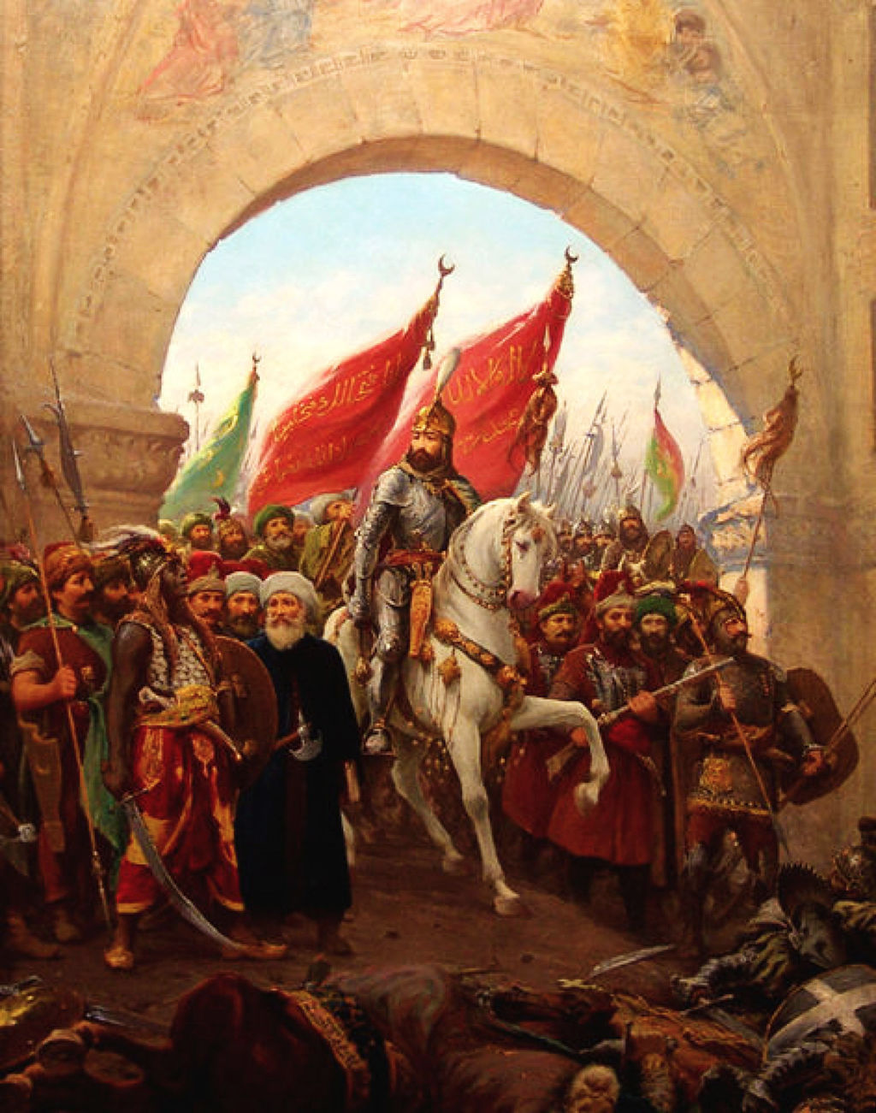  The entry of Sultan Mehmed II into Constantinople  Image is courtesy of Wikimedia Commons and is public domain. | 1453: Under the leader, Mehmet II, the Ottomans continued to expand and they captured the capital of the Byzantine Empire, Constantinople. Constantinople was renamed Istanbul and became the new capital of the Ottoman Empire. Hagia Sophia, a church, was turned into a mosque. After a 54 day siege and using a 27-foot cannon hauled by oxen and an advanced army with muskets [guns], Constantinople fell to the Ottomans.
- What message do you think the conquest of the Byzantine Empire sent to the rest of Europe?

- Why did the Ottomans convert the Hagia Sophia into a mosque?

- Why was this conquest a turning point in global history?

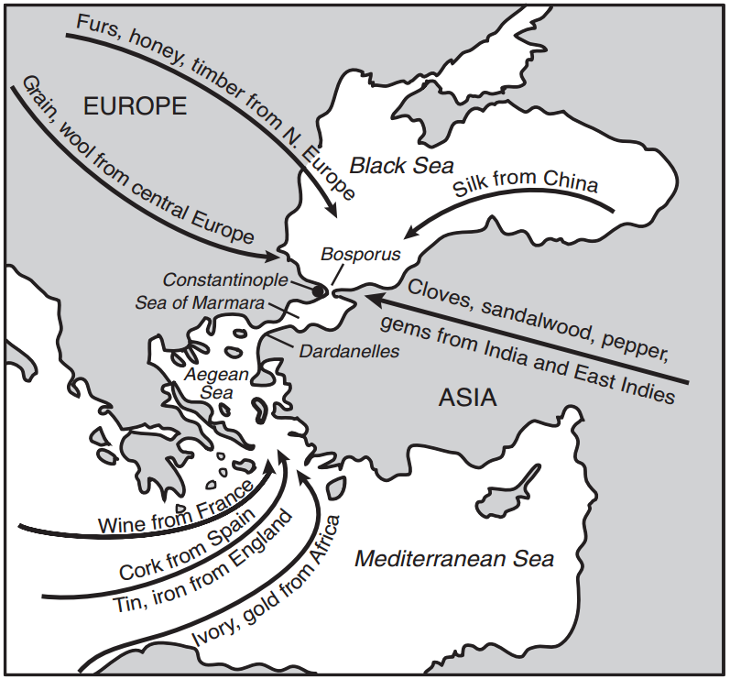  Adapted from the New York State Education Department.August 2007. Global History Exam. Internet. Available here; accessed July 16, 2017. | - Based on this map to your right, why was Constantinople so important to the Ottomans?

1520-1566: The Ottoman Empire had a golden age under the sultan named Suleiman. The Ottomans called Suleiman “The Lawgiver” and Europeans called him “The Magnificent.” Suleiman also developed laws and enforced the Islamic law of sharia. Suleiman had several accomplishments:  - Took on bold military campaigns that increased the amount of territory controlled by the Ottomans  - Increased naval strength which allowed them to conquer parts of North Africa  - Oversaw achievements of Ottoman civilization in the fields of law, literature, art, and architecture  - Built strong fortresses to defend his territories  - Adorned and modernized the cities of the Islamic world (including Mecca, Damascus, and Baghdad) with mosques, bridges, aqueducts, and other public works | 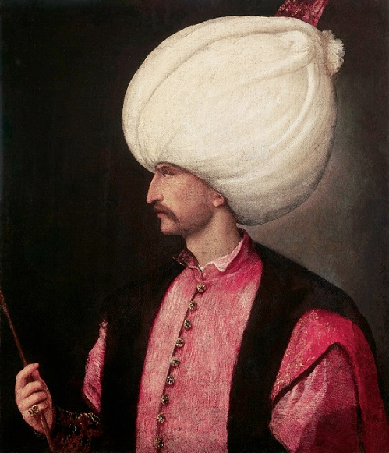  Suleiman I  Image is courtesy of Wikimedia Commons and is public domain.
- What were some of Suleiman’s achievements?

- Based on the information provided, could Suleiman’s rule of the Ottoman Empire be considered a Golden Age? Why or why not?

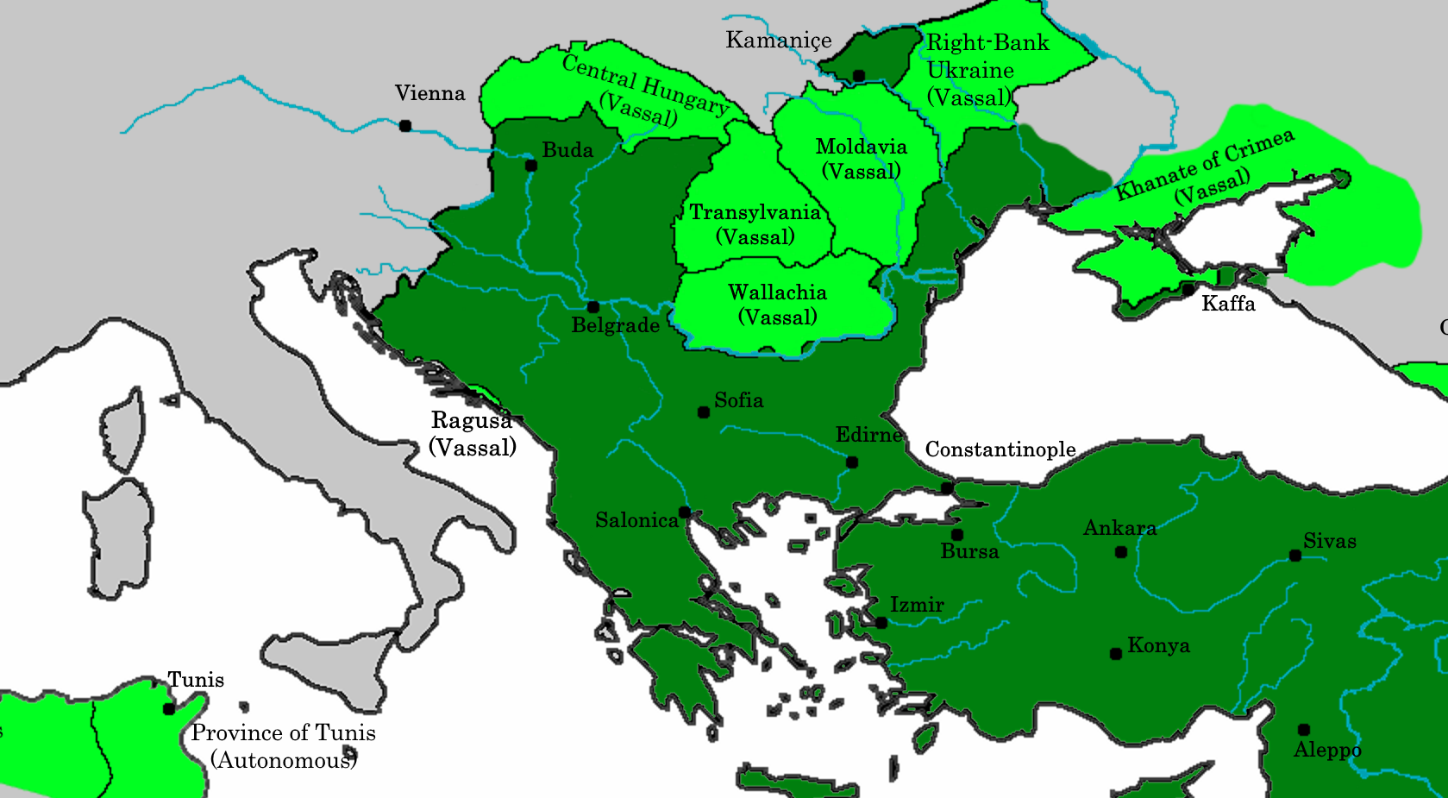  Image was created by Chambozi and is published on Wikimedia Commons under a CC BY license. | 1529: Suleiman’s army attacked the city of Vienna, which at the time was located in the Holy Roman Empire and today is located in modern-day Austria . This sent fear throughout Europe because it demonstrated how strong the Ottoman Empire had become and showed that they were a threat to European states. The Ottomans were unsuccessful in conquering Vienna, but they continued to be seen as a threatening empire seeking to conquer Europe.
 | - How might the siege of Vienna affect how Europe viewed the Ottoman Empire?

FA | SQ 2: What was the historical context for the founding of the Ottoman Empire?  ➡ Directions: Using evidence from the documents above, respond to the task below in the space provided.

Contextualize | Example: Fall of the Roman Empire  Who? Roman Empire  When? 476 CE  Where? Europe and North Africa  How?/Why? political turmoil, invasions, introduction of Christianity  Combined Context Expansion Sentences 1 In 476 CE, the Roman Empire which stretched across Europe and North Africa, collapsed because of political turmoil, invasions, and tensions caused by the introduction of Christianity. Writing Strategies Used: Prepositional phrase (In 476 CE) Conjunctions (because, and)  Combined Context Expansion Sentences 2 The Roman Empire, an expansive state that stretched across Europe and North Africa, collapsed in 476 CE due to political turmoil, invasions, and tensions caused by the introduction of Christianity. Writing Strategies Used: Appositives (...,an expansive state that stretched across Europe and North Africa,...) Conjunctions (due to, and)  Event: The Rise of the Ottoman Empire  Who?  When?  Where?  Why?  How?  Combined Context Expansion  Sentences

